Chapter 17 Study Guide
Since this is your first study guide of the year, let’s go over its purpose. It is intended to be a tool used by you independently as the chapter progresses. Information to answer the questions within could be derived from: the textbook, labs, lecture, Google, or asking your teacher or your friends. It should be worked on whenever you have free time in class or outside of class if those opportunities are not present. You should work your way through it gradually so that it is nearly complete by the day before the test. This allows you to ask any remaining questions on that day and use it as a study aid prior to taking the test. This will not be collected nor graded, but should become familiar with the framework since you will be expected to create your own later in the year.
Seasons
- What is the difference between rotation & revolution? (be sure to explain which is which!)

- What is responsible for the fact that the angle that the sun’s rays strike Earth at a particular location changes throughout the year?
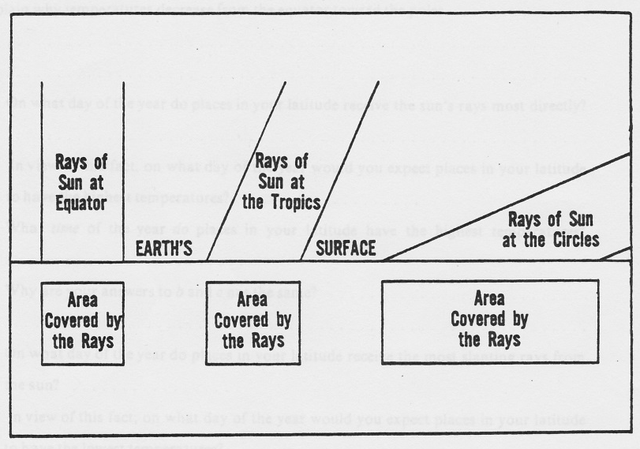
Consider the diagram below. A “bundle” of light rays is called a beam. The diagram shows three equal beams of sunlight striking Earth at three different latitudes. (0°, 23.5°, 66.5°)
- How do the amounts of energy in each beam compare?

- How do the areas of Earth’s surface covered by the beams compare?

- Which beam heats Earth’s surface the most? Why?

- Explain why average temperatures decrease from the Equator toward the poles.

- What is the latitude of the Tropic of Cancer? __________ Tropic of Capricorn?__________ What is the importance of these lines?

- On what dates is the sun directly overhead at the Equator?

- What name is given to these dates?

- On what dates is the sun directly overhead at the Tropics?

- What name is given to these dates?

- At the Equator, the length of day is always _______ hours. At all other places on Earth the length of day varies throughout the year.

- With an increase in distance northward from the Equator, the length of daylight ________________ in the summer and _________________ in the winter. On June 21, the number of hours of daylight is _______ hours at the North Pole and _______ hours at the South Pole.

- Explain why the North Pole is not the hottest place on June 21 since it receives a longer period of sunlight than anywhere else.

Earth’s Atmosphere
- Dry air (not including water vapor) consists mainly of 3 gases:
______________________ _____%
______________________ _____%
______________________ _____%
- Complete the pie graph to the right using this information. Provide a key.

Some of these gases, though of low concentration, have important functions.
- Water vapor is also extremely important. It is variable in concentration, from ______ to ______ %.

- Which gas surprised you as a result of its concentration? Why?

The atmosphere can be compared to an ocean, except it is (of course) an ocean of air.
- Have you swum in the ocean? ________ At what depth in the ocean did you swim? (Near the top, near the bottom, in the middle)

- Would you think it would be easy to swim near the bottom of the deep ocean? Why or why not?

- Where in the atmosphere do we spend our time? (Near the top, near the bottom, in the middle)

- Standard atmospheric pressure at sea level is around 14.7 pounds per square inch. Why are we not crushed by atmospheric pressure?

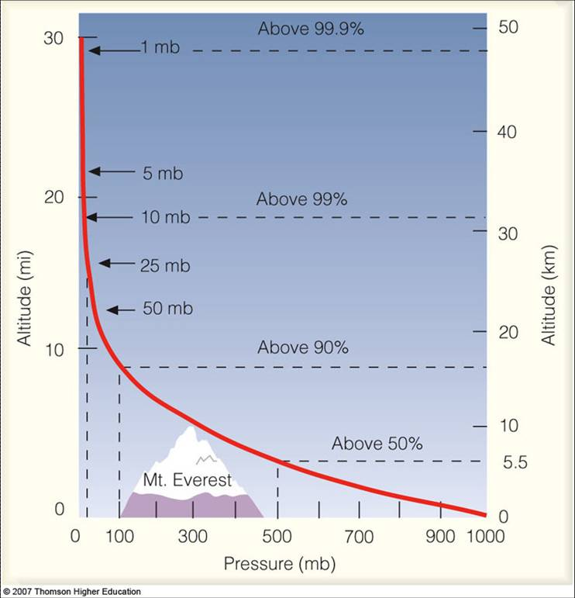
Consider the graph to the right of pressure compared to altitude.
Pressure is given in millibars, a unit we will consider later.
- Where in the atmosphere is the pressure the greatest?

- Surface pressure is approximately _________ mb.

- At what altitude is the pressure about half of surface pressure? (be sure to include units)

- The atmosphere is generally considered to be about 300 miles (480 km) thick. If this is true, what percentage of the entire atmosphere (by altitude) contains about half of the air?

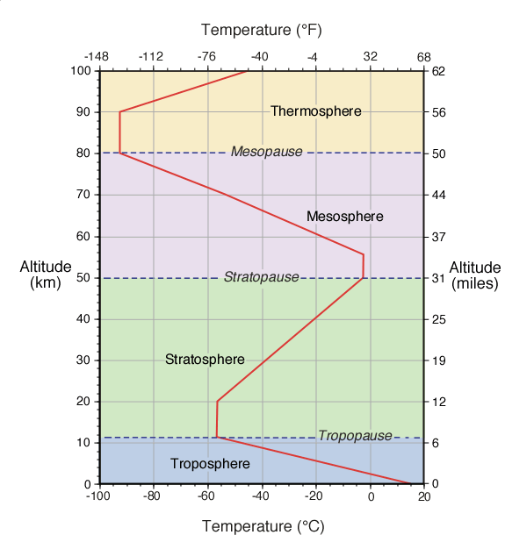
*Pressure is not the only measurable quantity that changes with altitude. Temperature also changes with altitude.
- In which layer of the atmosphere do you live?

- What happens to temperature of the air as you move upward from the ground through the troposphere?

- What happens as you go upward through the stratosphere?

- At what altitude is the boundary between the troposphere and the stratosphere?

- Why is the bottom of the troposphere the warmest when that part of the layer is farthest from the sun?

- Why does the stratosphere have a different profile than the troposphere?

Ozone (O₃) is a gas that forms in the stratosphere. The formation of the “ozone layer” in the stratosphere around 600 million years ago was of particular importance to the development of life on land. Prior to that life outside the ocean was not possible.
- What does the ozone layer do that would help life?

- What did humans develop in the mid 1900’s that began destroying the ozone layer, particularly above the poles?

- What impact could thinning of the ozone layer have on humans?

**Ozone releases the energy it absorbs in the form of heat. This warms the stratosphere and produces the temperature profile seen in the diagram above.
Energy in the Atmosphere
- What is the difference between heat & temperature?

- Heat energy is transferred in the atmosphere through 3 main methods: (name, describe, and give an example)

- Which process describes how Earth’s surface emits (gives off) energy it has absorbed?

- Which process describes how energy moves around in Earth’s atmosphere due to unequal heating?
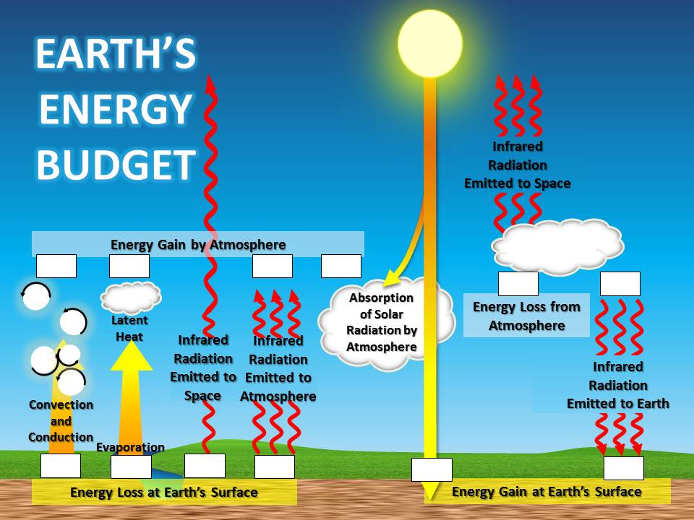
Energy radiated from the sun that enters Earth’s atmosphere is called incoming solar radiation or “insolation.” The fate of this energy is called the Solar Budget (or heat budget).
- Fill in each box in the diagram with the correct percent of the total insolation. What major process seems to be missing from this budget? (compared to the diagram in your book)

- Define albedo.

- Name a land surface that has a high albedo. Low albedo?

- How do you think the albedo of Earth’s surface might affect the climate of that region? (Compare land vs water or arctic vs Illinois)

Temperature Controls
- Land and Water heat differently. Does water change temperature more quickly or more slowly than land?

- Water behaves more like a material with a high albedo or a low albedo?

- Name at least 3 reasons why water heats differently than land. (in book)

- Would you expect hotter daytime temperatures in the summer in Wichita, KS or San Francisco, CA? Each are located at 38° North latitude, so each gets the same angle of sun and length of day. Explain.

- Proximity to water is one factor that controls the temperature of a place on Earth’s surface. Name 4 others:

- Would you expect hotter daytime temperatures in the summer in Ocean City, MD or San Francisco, CA? Each are located at 38° North latitude, and each are right by the ocean. Explain.

- Would you expect the difference between daily high and low temperatures (temperature range) to be greater on a sunny day or a cloudy day?

- Explain why some mountains are covered with snow year-round even though they are located on the Equator.

- Casablanca, Morocco and Canberra, Australia are both 30° from the Equator and located on the ocean. Explain why the temperatures are much higher in Casablanca in July.

- Explain why south-facing slopes in the Northern Hemisphere are free from snow much earlier in the spring than north-facing slopes.

- At what time of day do you expect the highest temperature of the day to occur? The lowest? Explain why it is not what most people expect.

A lapse rate is the rate of change in temperature that occurs with a change in altitude. It is usually expressed in °F per 1000 feet. The normal (typical) lapse rate in the troposphere is 3°F/1000 feet.
- Using the normal lapse rate, calculate the temperature of the air at the top of a 24,000 foot tall mountain if the air at the base, which is at sea level, is 70°F.

- Define temperature range:

- Define average daily temperature:

- Define average monthly & yearly temperature:

- The high temperature on a given day was 92°F. The low temperature was 68°F. What was the temperature range for that day? The average daily temperature?

